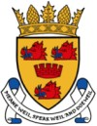 CROMARTY & DISTRICT COMMUNITY COUNCIL

INNER MORAY FIRTH PROPOSED LOCAL DEVELOPMENT PLAN - Nigg Energy Park

Photo taken 19th April 2022, Shore St., Cromarty
This could be our view by April 2032 or sooner, comment now. (PhotoShop).

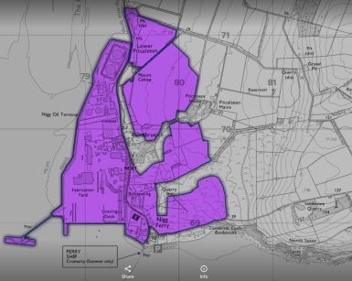
QUESTION: HOW DOES CROMARTY BENEFIT?
Comments can be submitted anytime between 25 March and 17 June 2022, via Highland Council website, log in or register at: https://consult.highland.gov.uk/kse/auth
https://consult.highland.gov.uk/kse/event/36514/section/s162919439784914#s1629194397849

For Nigg Energy Park see QR code:

From reading the IMFPDP, we understand the area opposite Cromarty could be industrialised in the short term. This could be good for the Highlands and the environment, but bad for Cromarty. The photoshop shows what this could look like. Of course it may not look, or sound, or have night time lights like this. But it may. We pose the question "how does Cromarty benefit?"- e.g. Income; lower cost electricity; year round ferry; employment; etc. - cromartydistrictcc@gmail.com

